
Release Notes v4.34.15
August 22, 2021

Visit Reason Permanently Displayed On Appointment Cards (No More Hover)

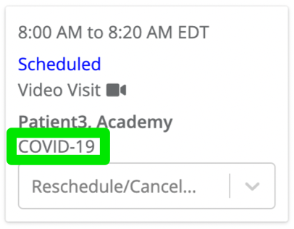

Print Button Added to Manage Appointments Tab

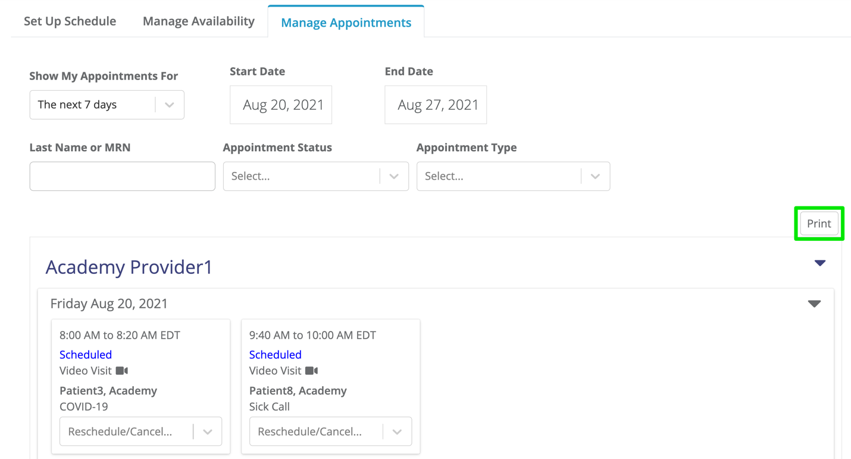
Patient Name On Appointment Cards Is Now A Clickable Link And Will Redirect You To That Patient’s Details Page

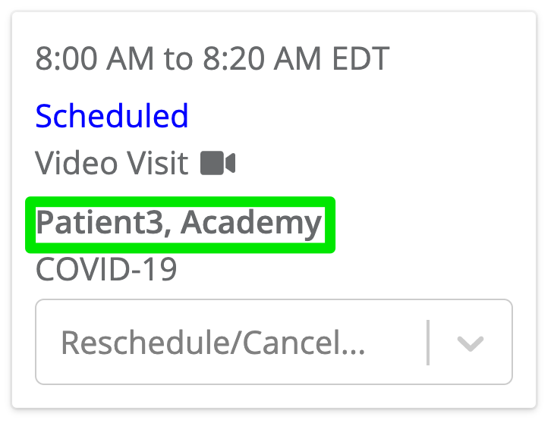

Today’s Appointments Have Been Added to Patient Care List View

You also have the ability to view appointments for multiple providers

